frontend: react
backend: python, fastapi
database: mysql

Summary of this system
Objective is to record company assets
1 login page ( Admin/ User)
1 user/admin Home report & Add edit page
1 Summary dashboard page
1 tables page

1) LOGIN FOR ASSET INVENTORY
- Users log in with username & password
- System verifies role: Admin / User
- Access is restricted based on role
- Tracks asset management securely
*Admin: Add/edit/delete assets, update depreciation, dispose assets, generate report
depreciation formula =
*User: Add new assets only, cannot delete or edit cost, generate report

2) CATEGORY ASSET INVENTORY
- IT & Electronic Equipment (Category)
Desktop/Laptop/Ipad/Tab/Monitor/Printer/Scanner/Server/Router & Network Switches/UPS (Uninterruptible Power Supply)/External Hard Drive (dropdown)

- Office Furniture (Category)
Office Desk/Office Chair/Filling Cabinet/Meeting Table/Discussion Table (dropdown)

- Office Equipment (Category)
Photocopier/Telephone/Fax Machine/Projector/Whiteboard (dropdown)

- Security & Facilities (Category)
CCTV Camera/Access System/Fire Extinguisher/Air Conditioner (dropdown)

- Pantry Equipment (Category)
Refrigerator/Coway Machine/Microwave (dropdown)

- Vehicle (Category)
Car/Van/Motorcycle/Lorry/Bus (dropdown)

- Stationery & Supplies (Category)
Staples/Paper Shredder/Calculator (dropdown)

- Miscellaneous (Category)
Company Mobile Phone/ID Card Printer/Time Attendance Device (dropdown)

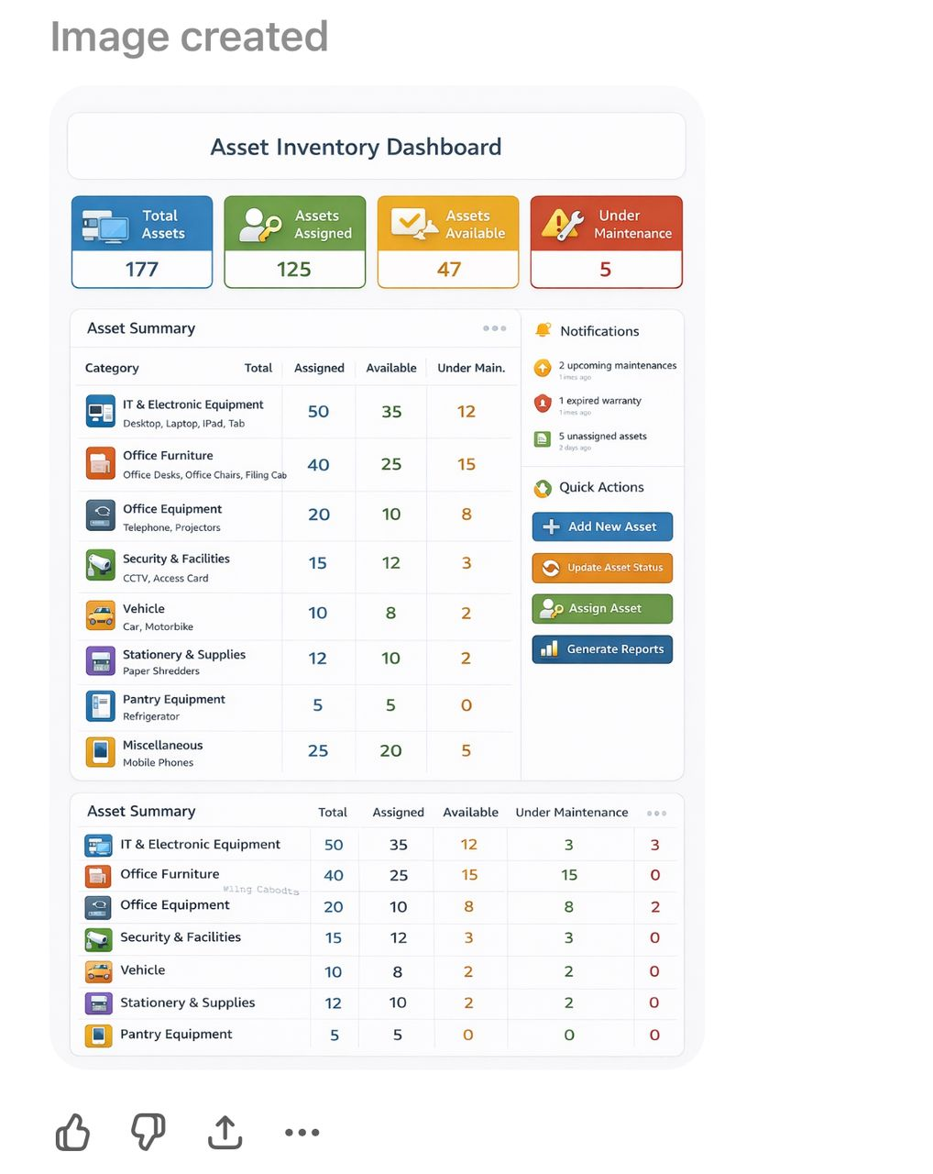

3)TABLE ASSET INVENTORY
- Example: Vehicle
  - Car
  - Van
  - Motorcycle
  - Lorry
  - Bus
*(dropdown)

Field
Asset Name -dropdown
Brand/Model- key in information
Serial No./Registration No. - key in information
Purchase Date (calendar)
Cost (RM) - key in information
Location/Department- key in information
Assign To - key in information
Condition-dropdown
Remarks/Additional Info- key in information

Asset Report By Category
No | Asset Name | Category | Brand / Model | Serial No. / Registration No. | Purchase Date | Cost (RM) | Location / Department | Assign To | Condition | Remarks / Additional Info
1 | Car | Vehicle | MAZDA X8 | SAZ100 | 15/2/2023 | 300,000.00 | IT Dept | Pn Sazlina | Good | 9 years financial
2 | Car | Vehicle | MAZDA X8 | ELI888 | 15/2/2023 | 300,000.00 | IT Dept | Pn Sazlina | Good | 9 years financial

base on cost the asset

Asset Summary Table
No | Category | Asset Name | Total (Unit) | Assigned  (Unit) | Available  (Unit)
1 | Vehicle | Car | 2 | 2 | 0
1 | IT & Electronic Equipment | Laptop | 10 | 8 | 2

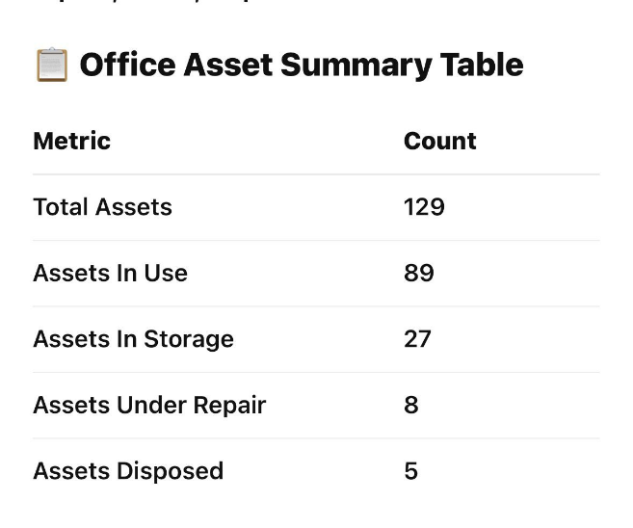

Edit changes
Log page
- choose role for user and Admin /

Home container padding issue alignment /

Dashboard
Show pantry, office, asset

Assets (Registration no, serial NO, code no - Same category)
date purchase
Location/department (
Category is not updated
Filter by Date
Tables generate by excel
expire items limit
Asset name allow them to key in
Add another maintainence unit & Disposal unit
Assest status for the dashboard, for disposed, use, maintanince and 1 more check
filter for

Office stationary

pantry expenses

